Dear Property Owner,
The Village of Shorewood has updated property assessments to maintain fair and equitable values as required by Wisconsin law. Using sales data up to January 1, 2025, this market update resulted in an average community increase of approximately 28.63%.
What Does This Mean for You?
Assessments are used to fairly distribute the tax burden. The property tax burden is redistributed after the market update based on all properties being assessed to fair market value.
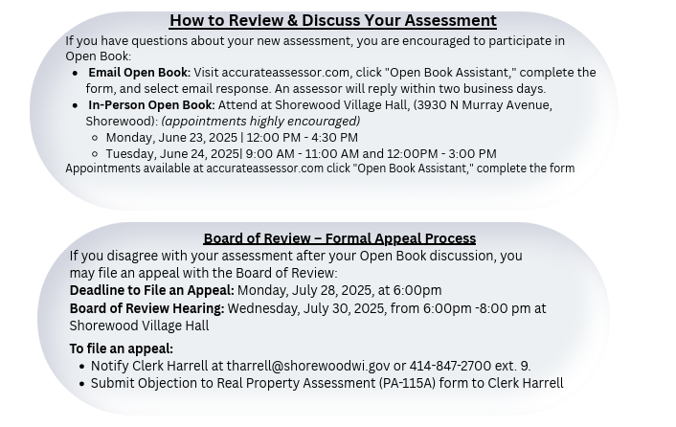
We encourage you to use the Open Book period for any questions. Signing up early ensures you and the assessor have sufficient time to allow for completion and avoid any last-minute delays.
Sincerely,
Accurate Assessor

accurateassessor.com | shorewoodvillage@accurateassessor.com | 920-749-8098

